

**HOUSING RENTAL MOBILE APPLICATION**

**By**

**NICHOLAS WAKABA**

**BSC/LMR/4914/17**

**Project Implementation Submitted for the study leading to a Project Report in partial fulfilment of the requirements for the award of a Bachelor of Science in Computer Science in St. Paul’s University.**

**Supervisor**

**SAMUEL MUTHEE**

**DATE TO BE SUBMITTED: April 2019**

# DECLARATION

This is to certify that the work being presented in the project entitled “**housing rental mobile application**” submitted by undersigned student of Degree in COMPUTER SCIENCE in the fulfilment for award of **Degree** in **Computer** Science is a record of my own work carried out by me under guidance and supervision of **Samuel Muthee** of the Department of Computer Science and that this work has not been submitted elsewhere for award of any other degree.

Name of student: **NICHOLAS WAKABA**

Registration Number: **BSC/LMR/4914/17**

Sign: __________________________________________

**APPROVAL**

This project was done and presented by me before the panel concerned in APRIL 2019 at St Paul’s University with my approval and that of my supervisor

**Supervisor Name**: ____________________________________________

**Signature**: ___________________________________

**Date**: ____________________

# ACKNOWLEDGEMENT

I want to give special thanks to The Lord God Almighty for allowing me to come this far and making it possible for I to do this project. I also want to highly appreciate everyone who chipped in to making this project a success. I would like to express my sincere thanks and deep sense of gratitude to my supervisor, Samuel Muthee for his valuable guidance, suggestions and constant encouragement which paved way for the successful completion of this phase of project work.

# ABSTRACT

I propose a housing rental android mobile application built with java to users. A user can search for a house to let in various places like district wise and local area wise. With the current paradigm shift in the technological field, there is an urgent need to embrace and appreciate the power of technology. Housing sector remains vigilant to face the challenges of change by employing a new strategy that facilitates easy access of rental houses. Distance vector routing protocols have been widely adopted as an efficient routing mechanism in current Internet, and many wireless networks. However, as is well-known, the existing distance vector routing protocols are insecure as it lacks effective authorization mechanisms and routing updates aggregated from other routers. As a result, the network routing-based attacks become a critical issue which could lead to a more deteriorate performance than other general network attacks. Hence there is need to develop a housing rental mobile application that can simplify work for the both the owner of the house and the tenant so that all their work can be efficient and effective. To get information about new rental houses that are currently being posted by the house owner, the user (tenant /house seeker) inputs values and information is filtered and displayed according to their inputs.

Table of Contents

DECLARATION 2

ACKNOWLEDGEMENT 3

ABSTRACT 4

CHAPTER ONE: INTRODUCTION 7

1.1 Introduction. 7

1.2 Background of the study. 7

1.3 Statement of the problem. 8

1.4 OBJECTIVES. 9

4.1.1 General objective. 9

4.1.2 Specific objectives. 9

1.5 Project justification. 9

1.6 Project scope. 10

2 CHAPTER TWO: LITERATURE REVIEW 11

2.1 Overview 11

2.2 Literature Review 12

4.1.3 Table Summary 16

2.3 Proposed System 16

2.4 System design 17

4.1.4 Design phases 17

2.5 System Architecture 18

3 CHAPTER 3: RESEARCH METHODOLOGY 19

3.1 Introduction 19

3.2 Research design 19

3.3 Facts finding techniques 19

4.1.5 Objectives 19

4.1.6 Questionnaires 20

4.1.7 Secondary Data Collection 20

3.4 SYSTEM DEVELOPMENT AND METHODOLOGY 20

4.1.8 Waterfall Model 20

4.1.9 System development and methodology Justification 24

3.5 Tools and justification 25

4.1.10 Android Studio 25

4.1.11 Java as the programming language for the housing rental application 25

4.1.12 Sqlite3 database 26

3.6 The project budget 27

3.7 WORK PLAN 28

Gantt chart 28

4 CHAPTER FOUR: SYSTEM DESIGN AND IMPLEMENTATION 29

4.1 System design 29

4.1.1 conceptual design 29

4.1.2 Database Design 29

4.1.3 Data flow Diagram 30

4.1.4 Rental mobile app Architecture 33

4.2 Implementation and Application description 34

4.2.1 Installation 34

4.3 Programming Language 37

4.3.1 Justification of the Programming Language 37

4.4 System Requirements 37

4.4.1 Hardware Requirements 37

4.4.2 Software Requirements 37

5 CHAPTER FIVE: SUMMARY, CONCLUSION AND RECOMMENDATION 38

5.1 Summary 38

5.2 User manual 38

5.3 Recommendation 38

5.4 Conclusion 38

5.5 References 39

5.6 Appendixes 40

5.6.1 Appendix A 40

# 

# CHAPTER ONE: **INTRODUCTION**

## **Introduction**.

Rental housing has become an important factor in modern society hence the need to have a rental house application to aid for rental housing management. This chapter will provide a brief understanding about background of study, definition of the project problem statement, its objectives both main and specific, project justification and its scope.

## Background of the study.

A home is a dwelling-place used as a permanent or semi-permanent residence for an individual. A home is one of the basic needs for human beings. Renting allows people who have no home, to live through paying rent to other people who have more houses. There are different renters who have different behavior that show different characteristics on rented people. Some renters may have a positive relationship, others may not. But here, what I have thought is how these people can find rooms or houses to rent without breaking a sweat, which is the focus of this project.

Most families or individuals choose to rent houses based on their income and family situations; unfortunately, finding a house based on these requirements may prove to be very tiresome.

Housing is a major problem in Kenya especially in Nairobi city. Millions of people are living in sprawling slams and also in other informal settlement around Nairobi without properly knowing their vicinity. There is emergence of the need to allocate rentals because you never know when an opportunity arises. Some rentals are very good but then again, the locality and availability become a menace.

The demand for rental houses is extremely high and more rental houses need to be put in place, hence marketing strategies for these houses become paramount. How do our customers know that “we” put up a new rental house or apartment and how as a tenant, do “I” know which rental house or apartment is vacant? Developing rental houses comes with many advantages especially to the Landlords who are able to increase their profits through rent paid by the tenants, but to the tenant sometimes finding a rental house becomes a level one menace.

## Statement of the problem.

Nairobi city doesn’t have an application that allow users to search, filter, review and book a rental house at the comfort of their current house or home.

There is no proper way to allocate a rental home and the only existing system is by use of adverts and billboards advertising for the same. This system is effective but not that quite operative when you think of the places where this marketing strategy for rental houses is not established.

There is no facility to help tenants look for a house or apartment just by the “click”. Sometimes tenants go through a horrible ordeal after finding themselves victims of fraud where they paid deposit for the so-called vacant room to an intermediate person who has no ties to that rental house in any way. These renders the owner of the house in lawsuits after been sued for fraud and to the tenant this leads them in to more trouble, cost, fraud and time wastage. The problem that exist is;

* Complexity of finding a rental house is not easy and is more tedious.
* Sometimes tenants end up paying extra money to find the rental house.
* The marketing system for these rental houses needs more human power.
* The user going door to door finding vacant rentals cannot get information about the rental.
* There is too match time consumption when finding the rental.
* Complexity during payment, where the tenant is not sure who they are paying to.

Real estate establishment for rentals has become difficult because of issues that include:

1. Population increase

Population increases day to day. As people get jobs and continue in their social life they need homes and at times they need to be close to their working areas hence the need for more rentals and effective marketing strategies for the same.

1. Lack of a computerized system

Currently most landlords/property managers use the manual system (advertisements and small billboards) to market their apartments to tenants and for the tenants there is no platform to find these apartments at the comfort of their current locale without using the manual system (door to door or asking a friend).

## OBJECTIVES.

### 1.4.1 General objective.

The main objective of the application is to develop a platform where tenants of Nairobi city can browse a variety of rental houses, filter them according to the location they wish to settle in, thereafter, they can continue browsing more rentals and filter them according to the type of rental home they looking for either single room, one bedroom, two bedroom or a whole apartment.

### Specific objectives.

In order to attain the general objective, the following are the list of specific objectives:

1. To facilitate a platform for the rental house owner to advertise their house by uploading details, images and terms and conditions via the application.
2. To prepare a rental application platform for the tenants to find homes.
3. To study and analyze the requirement specifications of the rental housing mobile application.
4. To produce the Software requirement Specification of the mobile application.

## Project justification.

Mobile applications are now widely used for the normal day to day activities because they are very convenient. Therefore, there is a need to develop applications in the world of real estate. My project focuses on the development of a mobile application that will change the world of real estate as we know it. It will solve one of the complex problems people encounter when they are looking for a rental house and that is; the location and availability of the houses. People are forced to go apartment to apartment looking for a vacant house or room to rent and at times, they go home without having found one because they can’t cover much ground on foot. The rental housing application will foresee that all these requirements are met and a tenant will be able to look for house according to location, price and type just by a click of a button. This rental housing application will be the miracle that happened to both tenants and house owners.

## Project scope.

The project scope defines the description of the work that is required in delivering the rental housing application. It features an **android based** application that will limit its main focus on rentals in **Nairobi, Kenya**. The following are the scopes of work during the course of the project:

* Study and understand the requirement of this project
* Construct Software Requirement Specification document for the application.

# CHAPTER TWO: LITERATURE REVIEW

## Overview

Literature review is very important as it facilitates the Identification of the problem that occurred in existing systems. Besides that, it also helps to identify the best approach to achieve the project goal based on the study. Literature review is a text written by someone to consider the critical points of current knowledge including substantive findings as well as theoretical and methodological contributions to a particular topic.

Housing management systems are a subclass of information gathering and management systems that seek to arrange and display information on house listings to a user upon selection of a specific preference (such as apartment, bedsitter, price range or location) using the user’s social environment (collaborative filtering approaches). A housing management system is a system which provides management of houses to a user or proprietor.

Rental housing systems are faced with complex, dynamic and interrelated changes in the production context related to population increase, increasing rental houses demand, scarcity of natural resources, volatile input and output prices, rising rent costs and administrative regulations. The pace, scale and even the direction of such changes are hardly predictable. Consequently, rental housing systems and management practices have to be continuously adapted by house proprietors to this changing world. This continuous adaptation calls for the development of innovations in rental housing systems. The section provides a comprehensive literature review and highlights the gaps which exist on the above-mentioned areas(Nandini & Subhashini, 2018).

## Literature Review

Android applications just like any other system can be implemented with a wide variety of languages like C, C#, C++, java, ruby on rails, python, or php. However, android applications are limited to mainly Java or kotlin during android applications development. Initially, java is the default language for Android development, but there’s a new programming language called Kotlin. Kotlin was officially released in February, 2016 after the existence of java as the android development language for over twenty (20) years.

The approach I will choose in developing the rental housing mobile android application will be the use of java and not kotlin. The use of java is defined by various factors opposing the use of kotlin. Technically android itself is built on java and has been in use by developers for a long time. It’s easy to learn, understand and works well for native as well as cross-platform applications. Furthermore, since android itself is built on Java, there are plenty of Java libraries that i will use in the development of the android application. Java also has a wide open-source ecosystem, it’s cross platform and its applications are lighter and more compact, even when compared to Kotlin applications, hence resulting in a faster application experience. It also yields a faster build process too, letting me code more in less time and thanks to its accelerated assembly with Gradle, assembling the rental housing android application becomes easier. These opposed to the use of kotlin approach in the development of the rental housing android application that shows a slower compilation speed compared to java.

Furthermore, kotlin is still new and the learning resources are limited thus, finding answers or solutions to problems that I will encounter during the rental application development process will be grim. Android application security has become imperative because, some applications and actually almost all mobile applications deal with sensitive information from the user. The register and login credentials fed in by the user need to be kept secure because as we advance in the world of internet of things, cyberattacks are rapidly too catching up and that’s why I will use the Distance vector algorithm, to present the security mechanism of the rental mobile application including the message exchange and update message security authentication mechanism. The suggested approach shows that the security mechanism can effectively verify the integrity and validate the freshness of routing update messages received from neighbor nodes. In comparison with exiting mechanisms like the singular-value decomposition orthe [secure distance vector routing information protocol](http://www.scs.carleton.ca/~kranakis/Papers/srip.pdf) (SDV, S-RIP), the proposed model is more suitable for the development of this application because, it provides enhanced security without introducing significant network overheads and complexity.

The classical Bellman Ford algorithm is used for computing shortest paths between any two given nodes in a graph. The distributed version of this algorithm (DBF) was the origin of most of the distance-vector routing algorithms and protocols that are in use today(Mack, 2006).

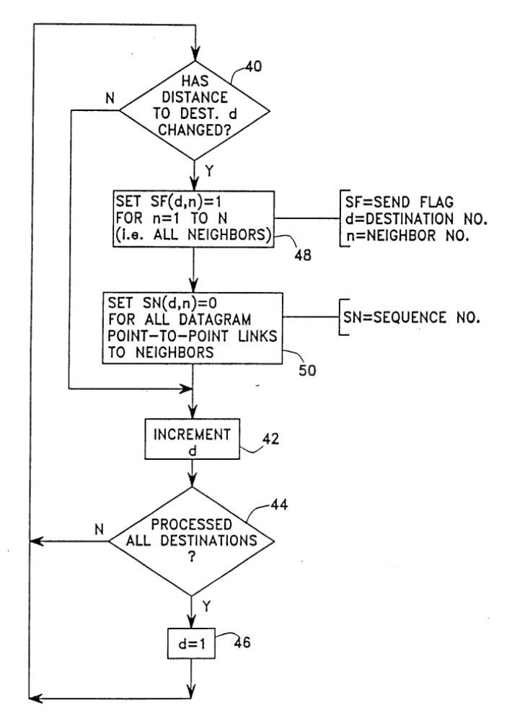

**Figure 1Distance vector algorithm**

**Related works**

Rental house management has become an important factor in modern society hence the need to have a rental house management system. A lot of systems have been developed to support the idea of finding rentals, because a home is a basic need for every person. Housing plays a huge role in revitalizing economic growth in any country, with shelter being among key indicators of development. The universal declaration of human rights gives one of the basic human rights as the right to a decent standard of living, central to which is the access to adequate housing (United Nations, The Human Rights-article 25,1948). The demand for rental houses is extremely high and more rental house need to be put in place. On that note, a lot of systems related to housing have been implemented. These systems allow proprietors to post rental houses and the potential tenants are allowed to search for houses to rent in order to secure a good standard home. Some of these systems include(Peter Gommans, Mwenda Njiru, Nguka Owange, & Proffessional, 2014);

#### Buyrentkenya

Buyrentkenya is a web application that was developed on the early days of the year 2019. It connects agents and developers with buyers and renters conveniently online. Tools used in developing this web application are, HTML, CSS, JavaScript, bootstrap, and Sql Server Database Management. It allows proprietors to post property and the potential tenants can search and contact owners. Many problems arise with web applications and that’s why developers are leaning on the other side of developing native mobile applications. Mobile applications are robust, quite simple and they allow inclusion of some functions that cannot be included in a web application like telephony management, camera and management of resources.

Buyrentkenya is one of the many web applications that are faced with this lack of diversity. Furthermore, as much as it offers services to users, it does not have map functionality. This allows a user to search a specific house and the location displayed on the system and all the use has to do is click start navigation. It also does not cover a lot of rental houses for low income earners but rather it covers apartments and property for sale. Moreover, it does not offer notifications to the user about new rentals or affordable rental listings because of lack of telephony management. Nevertheless, it covers a wide coverage of rental houses from different counties(“Property in Kenya - Rent &amp; Buy Real Estate | BuyRentKenya,”).

#### Expat

Expat is also web application that connects agents and developers with buyers and renters conveniently online. Tools used in developing this web application are, HTML5, CSS, and Sql Server Database Management. It allows users to post advertisements on housing and their contact information. Even though it also aids in solving the problem of finding a good rental home it too does not aid that well and does not cover rentals for low income earners. It lacks a map function to allow users to strategically place the location of the home they found exquisite. Furthermore, it does not have a variety of rental homes, updated information on the same and lacks a booking function. Nevertheless, it has a variety of items that one can advertise and post(“Expat.com, the expatriate community,” n.d.).

#### Jumia house Kenya

This is also a web application solely designed and developed for housing rental management in terms of buying, selling, and renting. It offers services like posting property and renting property. Its designed using tools like JavaScript, Bootstrap, HTML5, CSS and Oracle Database management. Nevertheless, it does not have map functions allowing a user to locate the house they want to buy and it also does not have a “book a house” function. Even though it is equipped with some flaws it does have a huge traffic of clients because its sole purpose is not only advertising houses but clients can also buy a variety of products as well(“Apartments For Rent in Kenya - Rent Flats| Jumia House,”).

#### Anza

Anza is a mobile application that offers rental services to potential clients looking for a house. Its developed in HTML, CSS, PHP and Sql Server Database Management. It has mapping functionality making it easier for tenants to find the nearby places around the house they want to rent. Proprietors can post vacant houses together with their contact details and wait for a call from potential tenants. Nevertheless, it doesn’t have updated information on the houses to rent, its not updated and it doesn’t have a lot of listings(“Anza - Where property search starts,”).

#### OLX

This is another web application that offers a lot of services to customers online. A client can sell their no more useful things online like, clothes, gadgets or even services. Furthermore, it also has a platform that facilitates the sale of houses and rentals. It is built in PHP, HTML5, BOOTSTRAP, CSS, and Oracle Database Management Server. It has a lot of services hence there is a wide traffic if customers using the web application. Nevertheless, there has been incidences of fraud and so a lot of people don’t rely on the site to look for houses to buy or rent so people prefer other alternatives(“Real Estate in Kenya | OLX Kenya,”).

### Table Summary

**Table 1 Related works summary**

|  |  |  |  |
| --- | --- | --- | --- |
| **Project Name** | **Strength** | **Tools used in implementation** | **Short comings** |
| **Buyrentkenya** | Covers a wide locale range | HTML, CSS, JavaScript, bootstrap, and Sql Server Database Management | No notifications to the user,  No telephony management, no mapping functions |
| **Expat** | A variety of items that one can post | HTML5, CSS, and Sql Server Database Management. | No telephony management, no mapping functions |
| **JumiaHouseKenya** | Huge traffic of clients | JavaScript, Bootstrap, HTML5, CSS and Oracle Database management | No mapping functions |
| **Anza** | Has a mapping function | HTML, CSS, PHP and Sql Server Database Management | No updated information,  Has no house listings variety |
| **Olx** | A variety of items that one can post | PHP,HTML5, BOOTSTRAP, CSS, and Oracle Database Management Server | No security mechanism to keep away fraudsters |

## Proposed System

A user will initially sign up and create an account. Once the user(tenant) logins into the application, it will automatically show a number of various vacant houses and locations. They will be able to filter their search using price, location and type of the house. On clicking a particular house post, information like owner name, house rent, address, mobile number, and location will be displayed. This information will be submitted by the owner of the house who will also be required to sign up and login and post their rental house offer with valid details. The location of the house will be displayed via maps to allow the tenant to visit the house location without asking for directions using navigation feature in the maps. The command buttons will allow manipulation of the database. If owner of the house wants to add data to the database all they will need to do is to c lick on new house then input data in the textboxes provided then c lick save and the data will automatically be saved. They will also be able to view data in the database by clicking Search button and the data will be displayed for them. If the owner of the house decides to cancel their data entry, they will simply click on cancel and it will be canceled. Furthermore, pictures of the places will be uploaded daily to the tenant as a new house offer is posted. The tenant can place a location in the favorite tab so as soon as anew house offer in that location is posted they will find it there.

## System design

System design involves transforming the software requirements into an architecture that describes its top-level structure and identifies the software components and develops a detailed design for each software components. For each requirement, a set of one or more design elements will be produced.

### Design phases

The user’s requirements document will be analyzed for better understanding of what is required of the system. Ways of implementing these requirements will be analyzed. Physical modules of the system will be designed and identification of the operating environment in which they will work on. The system is an android based application. The database will be updated each time the administrator (owner of the house); add, deletes or deletes data on the application. It’s only the administrator who will have access to the application to view or make changes when necessary. The application will be designed to allow the administrator to view, edit, delete and add data to the database. Each time a tenant comes, he/she is registered in the tenant registration table of the database with other relevant details about the tenant.

#### Conceptual Design

Conceptual design will be the very first phase of design in which drawings or solid models will be the dominant tools and products. The conceptual design phase provides a description of the proposed system in terms of a set of integrated ideas and concepts about what it is to do, behave and look like, that is understandable by the users in the manner intended. (**See figure 5)**

#### Database Design

The general theme behind a database is to handle information as an integrated whole. A database is a collection of interrelated data stored with minimum redundancy to serve the users quickly and effectively. After designing input and output, the analyst must concentrate on database design or how data should be organized around user requirement. The general objective is to make information access, easy, quick and flexible for other users(“What is a database?,” ).(**See figure 6)**

## System Architecture

Partially connected mobile applications can be divided into six architectural layers; user interface, user-client layer, client domain, client-server layer and then they are synced with server domain (web services), server data. The application will be built on a known set proven library, built in the background, and all of these will be exposed through Android interfaces. Some of these interfaces will include(Feiler, Lewis, Vestal, & Colbert, 2005):

* Activity Manager-It manages the activity lifecycle and the activity stack.
* Telephony Manager-It provides access to telephony services as related subscriber information, such as phone numbers.
* View System-It builds the user interface by handling the views and layouts.
* Location manager-It finds the device’s geographic location**. (See figure 9)**

# CHAPTER 3: RESEARCH METHODOLOGY

## Introduction

The term methodology means the technique and procedure adopted by conducting a research study. It outlines how data will be collected and the tools for collecting data, system methodology, the proposed system input and output, users, systems development tools, project budget and work plan.

## Research design

Research design is defined as a framework of methods and techniques chosen by a researcher to combine various components of research in a reasonably logical manner so that the research problem is efficiently handled. There are types of research designs; quantitative research design and qualitative research design. I will choose qualitative research design where exploratory design will be the key enterprise. Exploratory research is defined as a research used to investigate a problem which is not clearly defined. It is conducted to have a better understanding of the existing problem. Exploratory design gives a lot of flexibility and can adapt to changes as the research progresses. It is usually low cost and helps lay the foundation of a research, which can lead to further research. Furthermore, it will enable me to understand the problem more clearly.

## Facts finding techniques

It shows how data will be collected from the users of the system. The data collection techniques to be used include:

### Objectives

I will use this technique to collect information about how the current applications operate and their processes. This involves systematically watching and recording the behavior and characteristics of operations and processes. It gives more detailed and context related information and can adapt to events as they occur.

### Questionnaires

I will prepare a number of questionnaires whereby I will submit them to business owners (Landlords) to get a deeper insight of how the application is going to work. I prefer this method because it gives more information from various individuals and offers greater flexibility as the opportunity to restructure questions. This technique is preferred because it will provide a closer contact between the users and the developer hence dispelling the probability of the completed application being rejected by user(s). This technique also permits clarification, has high response rate than interviews, and helps get full range and depth of information.

### Secondary Data Collection

I will collect these data from existing sources e.g. books, internet, journals and magazines that were collected by other researchers and analysis was done. It is from these data that I will then compare with the primary data, make a decision and conclusion.

## SYSTEM DEVELOPMENT AND METHODOLOGY

System development methodology is a technique that is used to show how the proposed system will be developed. In this case, the methodology I use will be the waterfall model.

### Waterfall Model

It is comprised of the stages that the developer will use when developing the system. It is a sequential model hence, the name waterfall. The developer has to finish with one stage before going to the next one. It comprises of the feasibility study, analysis phase, design phase, coding phase, testing phase, implementation phase and finally the maintenance phase. It is a simple model and easy to use and understand. With waterfall development-based methodologies, the analysts and users proceed sequentially from one phase to the next. The deliverables from each phase are voluminous and are presented to the project sponsor for approval as the project moves from phase to phase. Once the phase is approved it ends and the next phase begins.

**Waterfall Model Diagram**

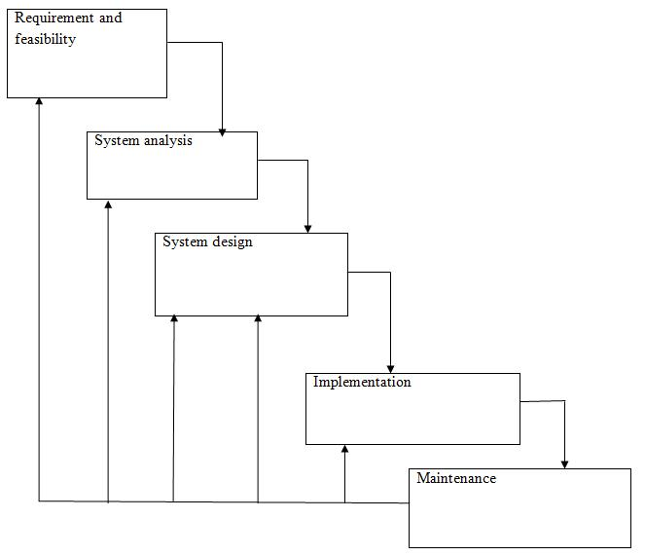

**Figure 2 Waterfall Model**

#### Feasibility study

Here, I will carry out a study to gain an understanding of the customers (tenants and house owners) current application and problems experienced in this application through interviews, observations, and participations. I will use the obtained data to determine the viability of the application being proposed in terms of technical, economic and social feasibility.

#### Requirement and analysis

Requirement analysis involves defining customer needs and objectives in the context of planned customer use, environments and identified system characteristics to determine requirements for system functions. At this stage, I will gather information about what the customer needs and define the problems the application is expected to solve. I will also include customers‟ business context, products functions and its compatibility. I will gather requirements such as software; like the programming language to use, database model and hardware needed such as laptop, and printers.

##### User Requirements

It entails user involvement and statements of facts and assumptions that define the expectations of the application in terms of mission objectives, environment, constraints and measures of effectiveness and suitability. Basically, the users want:

1. An application that improves on the efficiency of information storage and retrieval.
2. An application that is easy to learn and use.
3. An application that is fast in processing transactions.
4. An application that is flexible, safe and convenient.

##### Functional Requirements

This is a necessary task, action or activity that will be accomplished. The proposed application will be able to:

1. Allow administrator (owner of the house) to add houses, and Details
2. Allow the administrator to delete houses, and details
3. Allow the tenants to search data(houses) in the application database.
4. Allow the administrator to edit data(houses) in the application database.

##### Hardware Requirements

These are the hardware requirements needed for a user to run the housing rental mobile application.

1. A smartphone that has internet connectivity and;
2. A Processor with at least 1.0Ghz speed.
3. Memory of at least 1GB RAM.
4. A storage space to install additional components and environment where the application will run of at least 30MBs.
5. A Visual Display Unit of at least 800*600 colors mostly supported by almost all smartphones.

##### Software Requirements

1. Android version 4 and above.

#### System Design

At this stage, I will make an overall design of the application architecture and physical design which includes User Interface and application database design. It is at this stage that I will identify any faults before moving onto the next stage. The output of this stage is the design specification which is used in the next stage of implementation.

#### Coding/Implementation

Implementation is the stage in the project where the theoretical design is turned into a working system. The implementation phase constructs, installs and operates the new application. The most crucial stage in achieving a new successful application is that it will work efficiently and effectively. At this stage, I will begin coding as per the design specification(s). The output of this step is one or more product components built according to a pre-defined coding standard and debugged, tested and integrated to satisfy the application architecture requirement.

#### Testing

The purpose of the system testing is to consider all the likely variations to which it will be suggested and push the systems to limits. The testing process focuses on the logical intervals of the software ensuring that all statements have been tested and on functional interval is conducting tests to uncover errors and ensure that defined input will produce actual results that agree with the required results. Program level testing and modules level testing are integrated and carried out. At this stage, I will ensure both individual and integrated whole are methodically verified to ensure they are error free and satisfy user requirements. I will involve both unit testing of individual code module, application testing of the integrated product and acceptance testing conducted by or on behalf of customer. I will ensure bugs found are corrected before moving to the next stage. There are two major type of testing they are;

##### White box testing

White box is sometimes called “Glass box testing”. It is a test case design that uses the control structure of the procedural design to drive test case. Using white box testing methods, the following tests will be made on the application;

1. All independent paths within a module will be exercised once. In the application, I will ensure that case will be selected and executed checking all case structures. The bugs that will be prevailing in some part of the code will be fixed.
2. All logical decisions will be checked for the truth and falsity of the values.

##### Black box Testing

Black box testing focuses on the functional requirements of the software. This black box testing will enable me to derive a set of input conditions that will fully exercise all functional requirements of the application. Black box testing is not an alternative to white box testing rather it is complementary approach that is likely to uncover a different class of errors that white box methods may miss out like, Interface errors, Performance in data structure, Performance errors and, Initializing and termination errors.

#### Installation

It is done once the product has been tested and certified as fit for use. It is at this stage that the application will be installed on a smartphone after testing and certification that its efficient and bug free.

#### Maintenance

This stage occurs after installation. It involves modifications on the application to improve performance. Such changes are user initiated or as a result of bug a being discovered which was initially not known. These modifications will be recorded for documentation and application update.

### System development and methodology Justification

I will use the waterfall method as the approach for development since my project is small and requirements are very well understood. Moreover, Waterfall allows for departmentalization and control. A schedule can be set with deadlines for each stage of development and a product can proceed through the development process model phases one by one. Development moves from concept, through design, implementation, testing, installation, troubleshooting, and ends up at operation and maintenance. Each phase of development proceeds in strict order. Furthermore, it’s Simple and easy to understand and use, Easy to manage due to the rigidity of the model. Each phase has specific deliverables and a review process that are processed and completed one at a time. The stages are also well defined and the milestones well understood.

## Tools and justification

### Android Studio

I will use android Studio because it provides the fastest tools for building high quality and performant apps that run on every type of Android device, including phones and tablets, Android Auto, Wear OS by Google, and Android TV. As the official Android IDE from Google, Android Studio includes everything I need to build an app, including an intelligent code editor capable of advanced code completion, refactoring, and code analysis, a GPU Debugger to capture a stream of OpenGL ES commands on the Android device and replay it from inside Android Studio for analysis, a Fast and feature-rich Android Emulator with virtual accelerometer, ambient temperature, magnetometer, and other sensors, a Flexible Gradle-based build system that will offer build automation, dependency management, and customizable build configurations, a Built-in support for Firebase SDK, Firebase Test Lab, Firebase App Indexing, dbsqlite3 support, and Google Cloud Platform, an APK Analyzer to inspect the contents of my APK so that I can understand the size contribution of each component and moreover it is easy to use and has a Layout Inspector to examine my apps’ view hierarchy at runtime.(“| Android Developers,”)

### Java as the programming language for the housing rental application

The approach I will choose in developing the rental housing mobile android application will be the use of java and not kotlin. The use of java is defined by various factors opposing the use of kotlin. Technically android itself is built on java and has been in use by developers for a long time. It’s easy to learn, understand and works well for native as well as cross-platform applications. Furthermore, since android itself is built on Java, there are plenty of Java libraries that i will use in the development of the android application. Java also has a wide open-source ecosystem, it’s cross platform and its applications are lighter and more compact, even when compared to Kotlin applications, hence resulting in a faster application experience. It also yields a faster build process too, letting me code more in less time and thanks to its accelerated assembly with Gradle, assembling the rental housing android application becomes easier. These opposed to the use of kotlin approach in the development of the rental housing android application that shows a slower compilation speed compared to java. Furthermore, kotlin is still new and the learning resources are limited thus, finding answers or solutions to problems that I will encounter during the rental application development process will be grim.

### Sqlite3 database

SQLite is an opensource SQL database that stores data to a text file on a device. It is a software library that implements a [self-contained](http://sqlite.org/selfcontained.html), [serverless](http://sqlite.org/serverless.html),[zero-configuration](http://sqlite.org/zeroconf.html),[transactional](http://sqlite.org/transactional.html) SQL database engine. Android comes in with built in SQLite database implementation. SQLite supports all the relational database features. In order to access this database, I will not need to establish any kind of connections for it like JDBC and ODBC. An SQLite database can be queried and data is stored in a structured manner, it has higher performance, the android. Database and android. database. SQLite packages will offer a higher-performance alternative where source compatibility is not an issue, android-databases created in Android will be visible only to the application that created them, and the content will be viewed using third-party tools. Moreover, content will be updated continuously and automatically so that there will no work lost in the event of a power failure or crash.

## The project budget

|  |  |  |  |  |
| --- | --- | --- | --- | --- |
| **Item** | **Labor**  **(KSHS)** | **Unit** | **Other** | **Total**  (KSHS) |
| **Initiate project** |  |  |  |  |
| Conduct a feasibility study | 2000 | 0 | 0 | 2000 |
| **Requirement gathering and**  **Analysis** |  |  |  |  |
| ***User requirements*** | 2500 | 0 | 0 | 2500 |
| ***Functional requirements*** | 0 | 0 | 0 | 0 |
| ***Hardware requirements*** |  |  |  |  |
| Smartphone with;  Processer of at least 1GHZ,  Memory 1GB RAM,  30MB storage space, and  Visual display of 800*600 colors | 20,000 | 1 | 0 | 20,000 |
| ***Software requirements*** |  |  |  |  |
| Smartphone with android  version 4 and above |  |  |  |  |
| **Tools** |  |  |  |  |
| Android studio developer | 15,720 | 1 | 0 | 15,720 |
| Java development kit (JDK) | 0 | 1 | 0 |  |
| SQlite3 Database | 15,000 | 1 | 0 | 15,000 |
| **Testing** |  |  |  |  |
| Black box | 2500 | 0 | 0 | 2500 |
| White box | 2000 | 0 | 0 | 2000 |
| **Total** | 59,720 | 0 | 0 | **59,720** |
| **Total Estimated Budget (KSHS)** |  |  |  | **59,720** |

**Figure 3 Project budget**

## WORK PLAN

I will use the Gantt chart to show the work flow in developing the rental housing application in a duration of thirteen weeks.

### Gantt chart

**Figure 4 Gantt chart**

# CHAPTER FOUR: SYSTEM DESIGN AND IMPLEMENTATION

## System design

System design is the process of defining the components, modules, interfaces, and data for a system to satisfy specified requirements. System development is the process of creating or altering systems, along with the processes, practices, models, and methodologies used to develop them.

### conceptual design

Providing a description of the **rental mobile app** in terms of a set of integrated ideas and concepts about what it is to do, behave and look like, that is understandable by the users in the manner intended.



Figure 5 Conceptual Design

### Database Design

To make information access, easy, quick and flexible for other users and how data should be organized around user requirement for the **rental mobile app.**



Figure 6 Database Design

### Data flow Diagram

To show the flow of data in the **rental mobile app** and to also provide information about the outputs and inputs of each entity and the process itself.

#### Context Diagram



Figure 7 Context Diagram

#### Level 1 Data flow diagram



Figure 8 Data flow Diagram

#### ACTIVITY DIAGRAM



### Rental mobile app Architecture

To show the user interface, user-client layer, client domain, and client-server layer of the rental mobile app**.**

**The user-client layer, client domain, and client-server layer**



**Figure 9 Architectural Design**

#### The User Interface



## Implementation and Application description

The android application is implemented using Java Programming language. The platform or the integrated development environment I used was Android Studio. The minimum API level that is set is 19 and devices under this version are incompatible with the Application.

### Installation

The (Apk) is in the disk provided and you will need to copy in your phone and install it to start using the application. On installation the first activity is launched after the app launch or clicking on the newly installed Application called TOLET. The first activity Is the Account activity that requires a user to register either as a renter or owner of the house, or login if already an existing user.

The expected instance after the app launch should look like the pictures below.

On creation of an account and login as a renter or owner, the application will launch two distinct activities depending on the option one chooses as renter or owner. The as renter account will take you the renter’s dashboard where one can only view posted houses and get the details of the house owner and the house all together. He/she can send a message and make a call depending on the details provided via the application Moreover one can view the specific location of the house by clicking the preferred house.

If the user creates the owner’s account he/she can then have posting privileges of houses and write a description of the house for the renters to see depending on the type of the house (mess, sublet, hostel, flat).

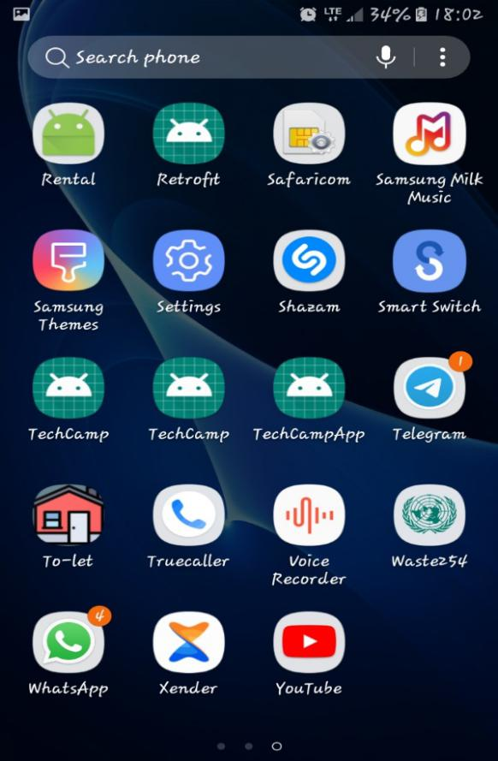 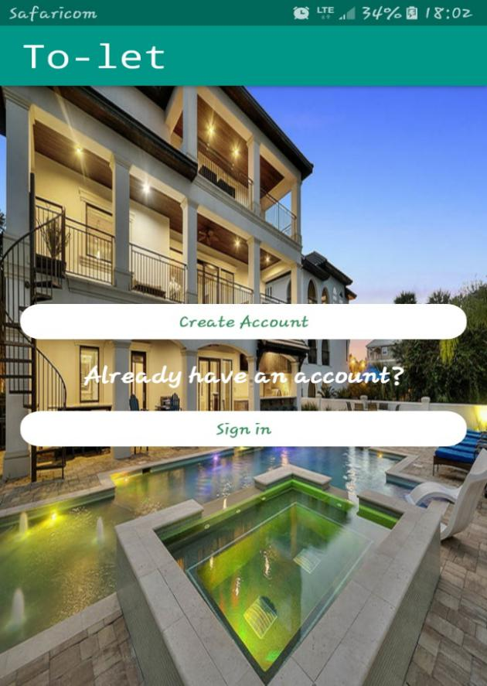

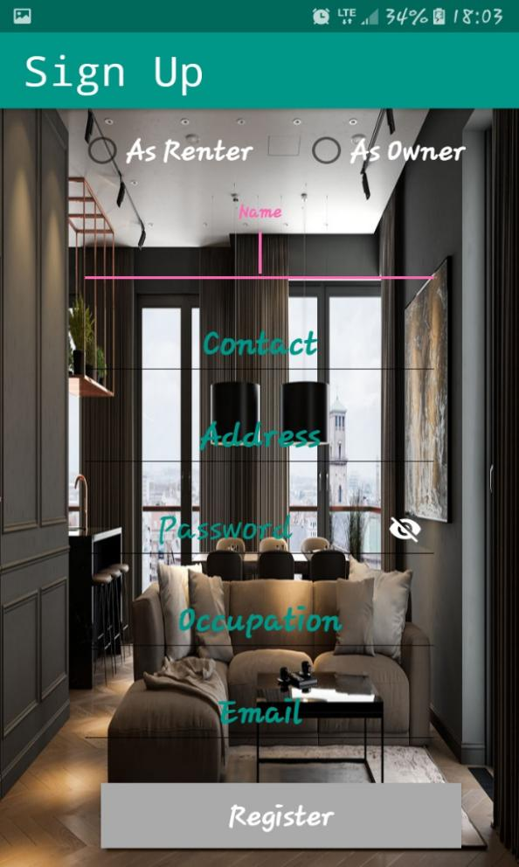 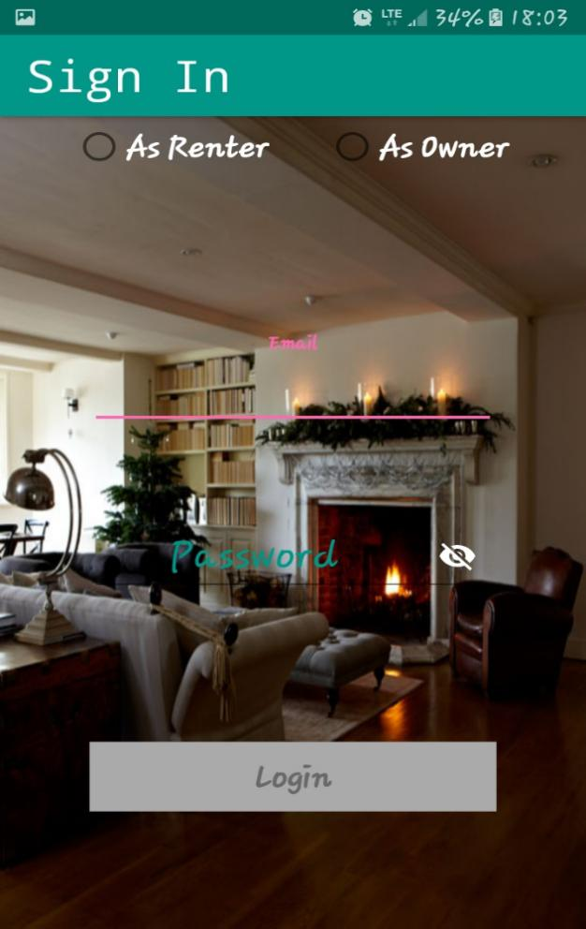

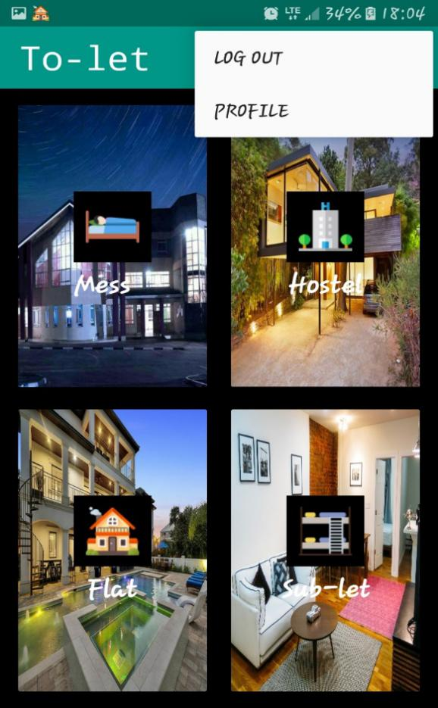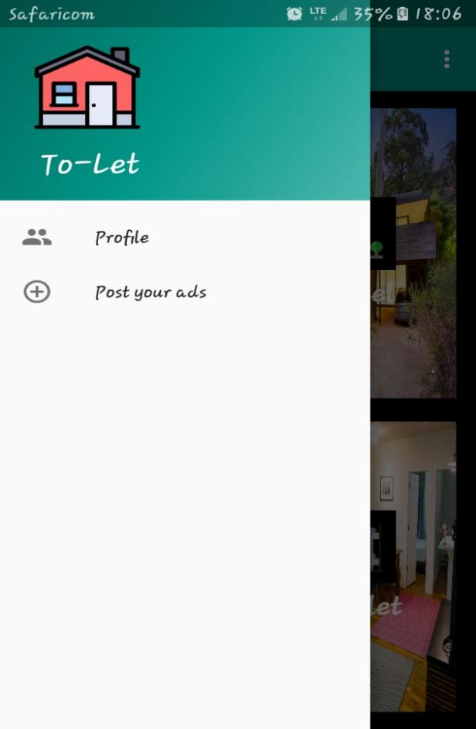

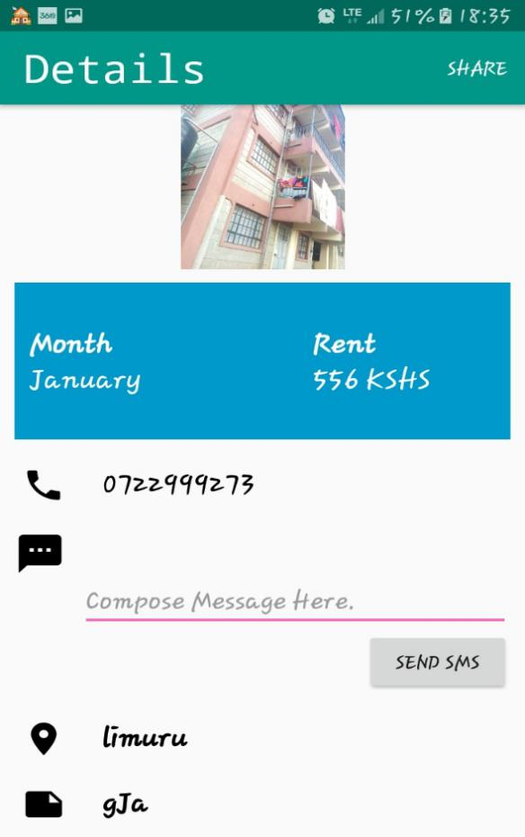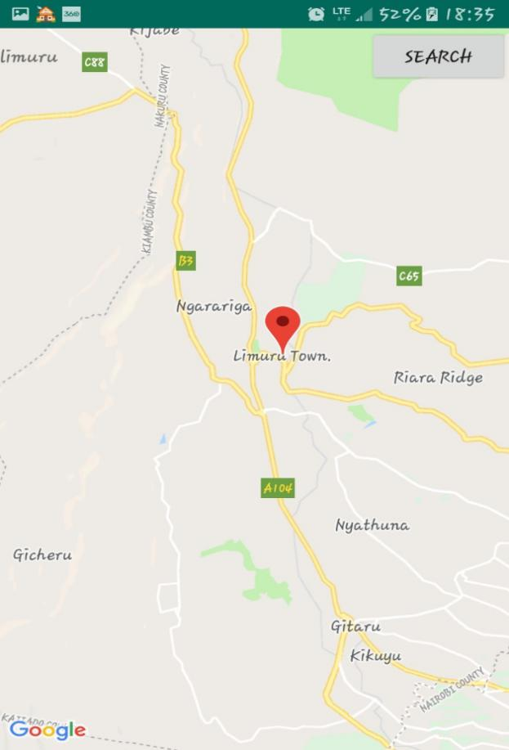

## Programming Language

The android application is development using JAVA programming language, which also integrates firebase, maps and xml all together to bring forth the TO-LET APP. A small code snippet is given in the Appendix section.

### Justification of the Programming Language

The use of java is defined by various factors opposing the use of kotlin. Technically android itself is built on java and has been in use by developers for a long time. It’s easy to learn, understand and works well for native as well as cross-platform applications. Furthermore, since android itself is built on Java, there are plenty of Java libraries that i will use in the development of the android application. Java also has a wide open-source ecosystem, it’s cross platform and its applications are lighter and more compact, even when compared to Kotlin applications, hence resulting in a faster application experience. It also yields a faster build process too, letting me code more in less time and thanks to its accelerated assembly with Gradle, assembling the rental housing android application becomes easier. These opposed to the use of kotlin approach in the development of the rental housing android application that shows a slower compilation speed compared to java. Furthermore, kotlin is still new and the learning resources are limited thus, finding answers or solutions to problems that I will encounter during the rental application development process will be grim.

## System Requirements

### Hardware Requirements

These are the hardware requirements needed for a user to run the housing rental mobile application.

1. A smartphone that has internet connectivity and;
2. A Processor with at least 1.0Ghz speed.
3. Memory of at least 1GB RAM.
4. A storage space to install additional components and environment where the application will run of at least 100MBs.
5. A Visual Display Unit of at least 800*600 colors mostly supported by almost all smartphones.

### Software Requirements

1. Android version 4 and above.

# CHAPTER FIVE: SUMMARY, CONCLUSION AND RECOMMENDATION

## Summary

The android Application is a user-friendly application that will help the user to post houses and view houses upon availability. It incorporates the calling and messaging function within the application to help the users have ease while navigating through the application. Prior to just calling and messaging the application also helps the renter view the location of the posted house under the house descriptions. The user can either register as a renter or owner and login as the same to view the distinct privileges of either the renter or owner. To get information about new rental houses that are currently being posted by the house owner, the user (tenant /house seeker) inputs values and information is filtered and displayed according to their inputs.

## User manual

* The user can be anyone with a smartphone that has android 5.5 and above with an API level of 21 and above. Find the APK in the Disk Copy it your smartphone, allow Install from Unknown Sources, Double Click the APk and wait for installation to complete then open the App.
* The user first needs to install the APK on their smartphone and launch the Application after installation is successful.
* The user can either register as a renter or owner if he/she has not account already.
* Upon registration the user can then decide on the action they want to perform either search of rentals or post rentals.
* The application is user friendly and doesn’t require a lot of technical knowledge to use it.

## Recommendation

This android application can be used by real estate companies, the government in civil houses allocation, any individual with a new house property to let. It is best suited more for advertising but it can be used for houses management, or administration of the owner’s houses.

## Conclusion

My idea was to bring forth an application that would revolutionize the world of real estate and hence make it easier for people to find affordable housing. The android application called TOLET has hence made it easier for renters and house owners to do that. The development went smoothly though with some difficulties but then again it was for the great of good. An interesting future development may be done to integrate Artificial intelligence to help in security like authentication and authorization.

## References

Android Developers. (n.d.). Retrieved March 19, 2019, from https://developer.android.com/distribute/best-practices/develop/build-with-android-studio

Anza - Where property search starts. (n.d.). Retrieved March 8, 2019, from http://www.anza.co.ke/

Apartments For Rent in Kenya - Rent Flats| Jumia House. (n.d.). Retrieved March 8, 2019, from https://house.jumia.co.ke/apartment/for-rent/

Expat.com, the expatriate community. (n.d.). Retrieved March 8, 2019, from https://www.expat.com/

Feiler, P. H., Lewis, B., Vestal, S., & Colbert, E. (2005). An Overview of the SAE Architecture Analysis & Design Language (AADL) Standard: A Basis for Model-Based Architecture-Driven Embedded Systems Engineering. *Architecture Description Languages*, 3–15. https://doi.org/10.1007/0-387-24590-1_1

Mack, C. C. (2006). *Rental Housing*. *Financial Analysts Journal* (Vol. 5). https://doi.org/10.2469/faj.v5.n1.22

Nandhini, R., & Subhashini, S. M. (2018). RENTAL HOME SYSTEM FOR NEAREST PLACE I . INTRODUCTION II . PROBLEM STATEMENT, *119*(10), 1677–1686.

Peter Gommans, H., Mwenda Njiru, G., Nguka Owange, A., & Proffessional. (2014). Rental House Management System. *International Journal of Scientific and Research Publications*, *4*(11), 2250–3153. Retrieved from www.ijsrp.org

Property in Kenya - Rent &amp; Buy Real Estate | BuyRentKenya. (n.d.). Retrieved March 8, 2019, from https://www.buyrentkenya.com/

Real Estate in Kenya | OLX Kenya. (n.d.). Retrieved March 8, 2019, from https://www.olx.co.ke/real-estate_c16

What is a database? (n.d.). Retrieved March 21, 2019, from https://www.usg.edu/galileo/skills/unit04/primer04_01.phtml

## Appendixes

### Appendix A

